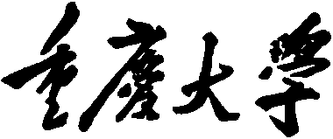


Personal Learning Portfolio

Course： English Academic Writing Teacher： Zhang Mei
Class： 001 Major： CS
Name： Student Number：
Class Time： 2024.02-2024.06
Grade：

Self | Teaching Assistant | Teacher
9

Comments：

Teacher (Signature)
Contents

Research Methodology
- My learning
- In class
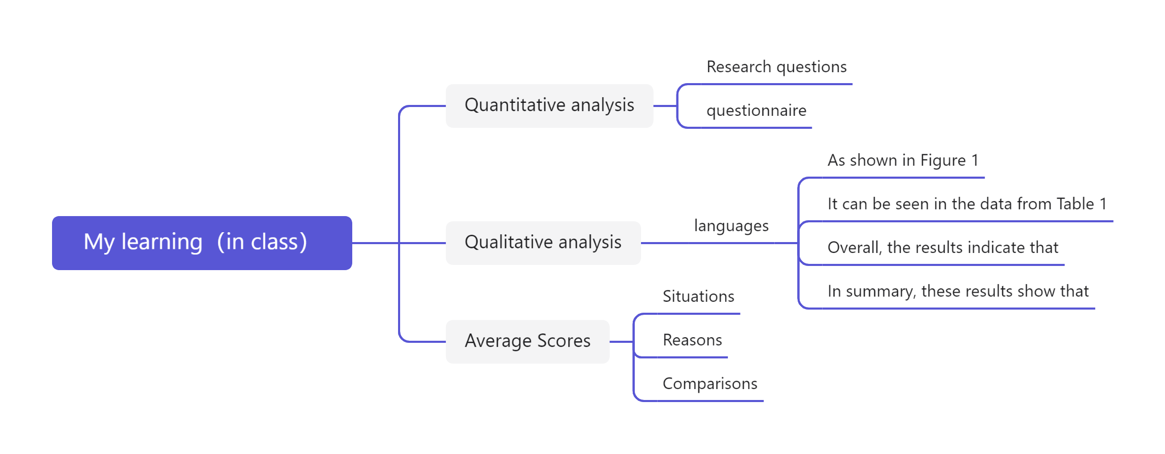
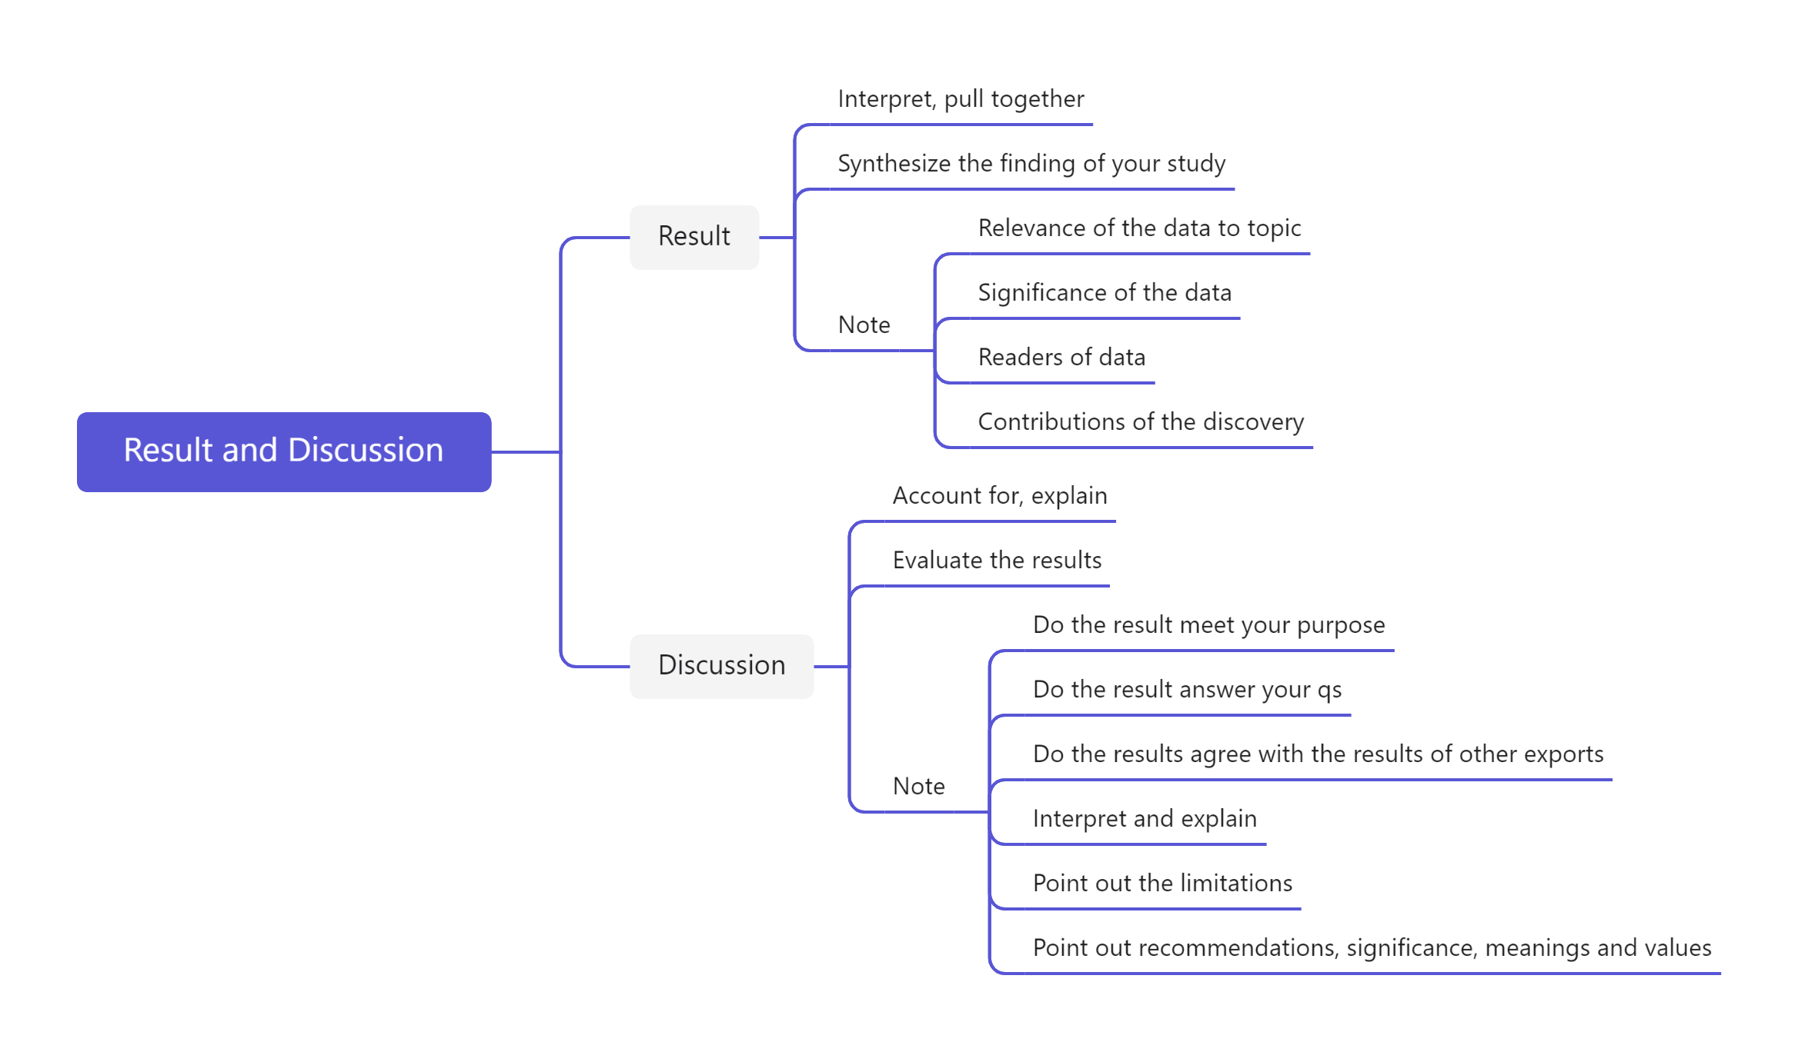
- Learning outcomes
1）In class
1) When I do data analysis, I focus on the research question and the results of the questionnaire.
2) When I do data analysis, I will do it from three aspects: the results of the survey, the reasons for the results, and the comparison of sample data.
2）Out of Class
1) When I have results and discussions, I should focus on the in-depth analysis of the problem.
2) When I present the results, I should interpret and synthesize the results of my research.
3) When I discuss the results, I should explain the results of the assessment in depth.
3. My behavior and attitude
1）Out of Class
1.1 Autonomous learning (Online + Offline)
1.1.1 Online (CET-6 online course)
1.1.2 Offline (memorize vocabulary and listen to CET-6 listening exercises)
1.2 Homework
I completed my English assignment promptly with a diligent and meticulous attitude, ensuring it was not procrastinated until the deadline.
1.3 Cooperative learning
2）In Class
2.1 Individual performance (Take notes promptly and attentively focus during class).
2.2 Cooperation (Actively participate in classroom discussions)

4．Improvement
1）Out of Class
This week, I memorized CET-6 words outside of class and conducted Level 6 listening training, which greatly improved my CET-6 test-taking ability。
2）In Class
In this week's course, I learned how to write a research report and discussion section, and I also mastered the relevant presentation skills through the presentation task.

